

Assignment

Stage 2 - MVP and Sprint Plan

Project: Family Travel Companion

Team Number:

Module Details
Course/Module: COM435 - Software Product and Process Management

Team Members
Team Number:
Contributing Team Members (list below: Surname, first name (Student ID)):

1. Contributing Team Members and Roles
The following table details each team member, their primary and secondary Agile Scrum roles, and a summary of their individual contribution to this CW1 stage 2 report. The Scrum Master for this project is Shajid Ahmed, who facilitated sprint ceremonies and coordinated the team's Trello board throughout. The Product Owner is Washif Hasan Piyal, who guided backlog prioritisation and MVP definition.

Name | Fist Role | Second Role | Individual Contribution
Shajid Ahmed | Scrum Master | Developer | Led sprint planning, facilitated stand-ups, coordinated communication, prepared the Story Map and Development Tasks sections of this report.
Washif Hasan Piyal | Product Owner | UI/UX Designer | Prioritised backlog, designed wireframes and Figma prototypes for F1 (Itinerary). Prepared wireframe rationale and MVP description.
Shafema Alam Shithy | Developer | QA Analyst | Authored development tasks for S21 and S14. Prepared test cases for S10 and S21. Contributed to conclusion and references.
Labiba Ahmed Nowshin | Developer | Tester | Authored test cases for S6, S24, and S28. Reviewed acceptance criteria alignment across all test cases.
Mofojjul Ali | Developer | Documentation Lead | Maintained sprint minutes and Trello screenshots. Authored test cases for S30 and S14. Compiled appendix materials.

2. Introduction
This report is the second phase of the coursework for COM435 Software Product and Process Management on Family Travel Companion, a mobile and web application that targets families with children and helps them to plan their trips simply and effectively. Stage 2 takes the team from discovery to structured planning and early delivery, turning those user stories into a release-ready plan by the interdisciplinary team of product strategy, interaction design, technical specification, and quality assurance.

The team has continued to adopt the Agile Scrum framework as the methodological backbone of this stage. According to Schwaber and Sutherland (2020), a Sprint is a time-boxed, goal-driven activity that transforms the chosen backlog items into a potentially releasable product increment. This principle regulates the five two-week sprints mentioned, each illustrating the feasible production of a five-person team working at a sustainable pace. The framework's iterative and incremental nature is particularly well-suited to the Family Travel Companion, where user needs across family members, business partners, and platform administrators are diverse, interdependent, and subject to refinement as understanding deepens.

The Minimum Viable Product (MVP), applying the prioritisation logic of the Kano model (Kano et al., 1984) to distinguish must-have features those delivering baseline functional satisfaction from performance and delight features deferred to later sprints. The MVP encompasses eight user stories spanning user registration, itinerary creation, destination search, budget management, accommodation and experience listings, document storage, and business verification: a coherent end-to-end workflow that validates the product concept with the least investment, consistent with Ries's (2011) principle of validated learning.

In story map, constructed following Patton's (2014) methodology of organising user activities across a backbone of system themes and slicing them horizontally into sprint releases. The mapped out plan arranges all the thirty user stories within five sprints. It starts with authentication and main planning in Sprint 1, then moves to gamification, collaborative tools, and corporate integrations in Sprints 2 to 4, and finally to performance testing and deployment preparation in Sprint 5. Wireframe designs were created for six Sprint 1 features. Each varies in three design alternatives (3-up) before deciding on one refined design (1-up) and a high-fidelity prototype in Figma. Twelve development tasks were carried out for four user stories. This is a kind of technical breakdown that implementation teams need. Thirty structured test cases were made for ten user stories. They turn each story's acceptance criteria into reproducible, step-by-step test procedures, following the standard software testing methods (Myers et al. 2011). When all are combined, these artefacts serve as a thorough, consistent, and team-authored roadmap for Family Travel Companion's product delivery.
3. Minimum Viable Product (MVP)
The Minimum Viable Product (MVP) for the Family Travel Companion is defined as the smallest set of features that delivers genuine value to the platform's primary stakeholder group individual family members planning group trips while also establishing the marketplace infrastructure required to attract travel and hospitality businesses. The MVP encompasses Sprint 1 deliverables and the core Sprint 2 stories, providing a coherent and independently usable product at the point of initial release.

3.1 MVP Feature Set
The following capabilities constitute the MVP scope:
User Registration and Authentication (S1): Families may register using their email or social media (OAuth) and log in securely. Role-based access control will identify family members, business users, and platform administrators.
- Multi-Day Itinerary Creation (S2): This main planning feature lets family members build named, date-bounded itineraries with a day-by-day layout. It represents the main user flow of the product.

- Destination and Activity Search (S3): Families can explore destinations and activities by filtering the location, date range, and budget, thereby bringing up relevant listings from the marketplace.

- Budget Management (S5): Families have the ability to set their trip budget, allocate the costs to activities and bookings, and keep track of their total spend, which essentially meets the financial planning part of family travel.

- Accommodation Listings (S6): Verified hospitality businesses, with the help of listing creation photos pricing, and availability, are capable of enabling families to find and evaluate lodging options.

- Tour and Experience Listings (S10): Tour and workshop hosts can publish via the platform pricing and photos, thereby diversifying the experience discovery in the destination.

- Travel Document Upload (S28): Families are enabled to upload and securely store filed travel documents (passports visas booking confirmations) in encrypted cloud storage.

- Business Account Verification (S24): Platform administrators will have the ability to examine and approve business and host applications to ensure that only genuine partners are listed in the marketplace.

3.2 MVP Rationale
To set the MVP scope, the team chose these eight user stories for three main factors. First, they are the MVP user journey: a family member signing up creating a trip finding accommodation and activities managing the budget storing travel documents. This complete cycle demonstrates that the product idea is viable (Ries, 2011). Second, since the online marketplace has both supply (S6, S10) and demand (S3) sides, it is imperative that they be functional at the same time. A searching feature without any listings or listings without any possibility to search will lead to a very poor user experience. Third, stories that have been postponed to future sprints (team coordination challenges corporate perks) are basically staff features from the Kano perspective; nice to have but not the main elements of the MVP value proposition.

4. Story Map
The story map below organises all thirty user stories from the Part 1 backlog across five two-week sprints. Columns represent thematic groupings of features; rows represent sprint boundaries. Sprint 2 introduces collaborative planning, gamification, and media features. Sprints 3 through 5 layers in community, corporate, and administrative capabilities, concluding with integration testing and deployment preparation.

THEMES | User Management & Auth | Itinerary & Trip Planning | Marketplace & Listings | Documents & Media | Admin & Notifications
FEATURES | F1: Family Member Accounts | F1: Itinerary Planning | F2, F3: Business & Host Listings | F8: Travel Documents & Memories | F5, F7: Admin & Tourism
SPRINT 1 | S1: Register/Login with email or social media | S2: Create multi-day itinerary | S6: List accommodation with photos & prices | S28: Upload travel documents (passports, visas) | S24: Verify & approve business accounts
 | S3: Search destinations by location/date/budget | S5: Manage trip budget & track expenses | S10: List tour/workshop with description & price |  | S25: Manage content quality & flagged listings
SPRINT 2 | S4: Join family-friendly challenges & earn badges | S14: Coordinate group trips for students | S7: Create special family offers & discounts | S29: Create digital photo album from trips | S20: Send real-time safety alerts to travellers
 |  | S15: Send digital permission slips to parents | S8: Update availability calendar in real time | S30: Write journal entries per trip day | S26: Ensure GDPR-compliant data management
SPRINT 3 | S27: Monitor user engagement & support inquiries | S17: Share curated itineraries for local areas | S11: Set maximum group size for activities | S16: Generate participant manifest with emergency contacts | S19: Publish event calendar for local festivals
 |  | S18: Post transport & accessibility information | S12: Specify age-appropriate activities
SPRINT 4 |  | S9: Receive instant booking notifications | S21: Offer travel perks & discounts to employees |  | S13: Cancel activity & auto-notify booked families
 |  |  | S22: Create travel bundles for employees
SPRINT 5 | Performance testing & bug fixes | End-to-end integration & regression testing | S23: Track redemption of travel perks | Security audit & penetration testing | User acceptance testing & deployment preparation

5. Wireframe Designs and Rationale
For each feature, three design variations (3-up) were created to explore contrasting approaches to layout, navigation, and interaction patterns. A single refined version (1-up) was then selected based on usability principles and team rationale, before being realised as a high-fidelity Figma prototype. The features selected are: (1) Multi-Day Itinerary Creation, (2) Destination & Activity Search, (3) Accommodation Listings, (4) Trip Budget Management, (5) Travel Document Upload, and (6) Digital Photo Album.

Team
Feature 1: Create Multi-Day Itinerary

3Up Wireframe Exploration
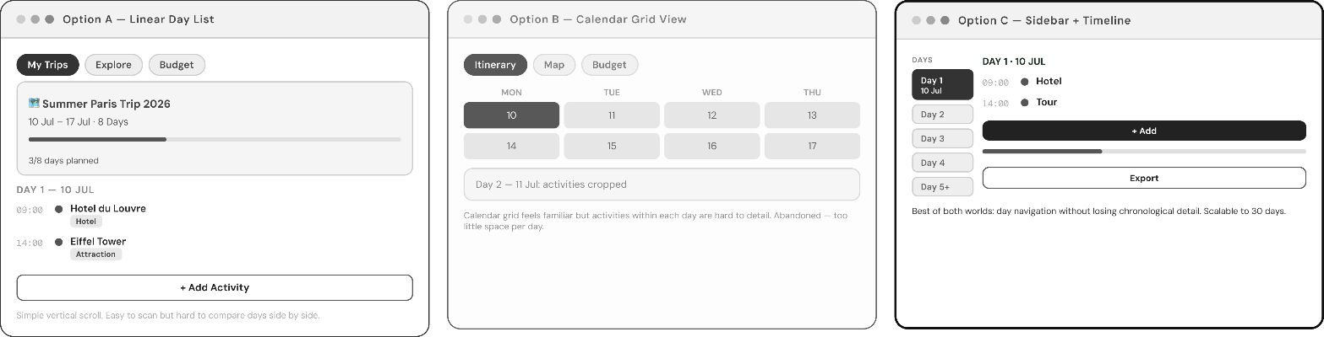

High-Fidelity Design
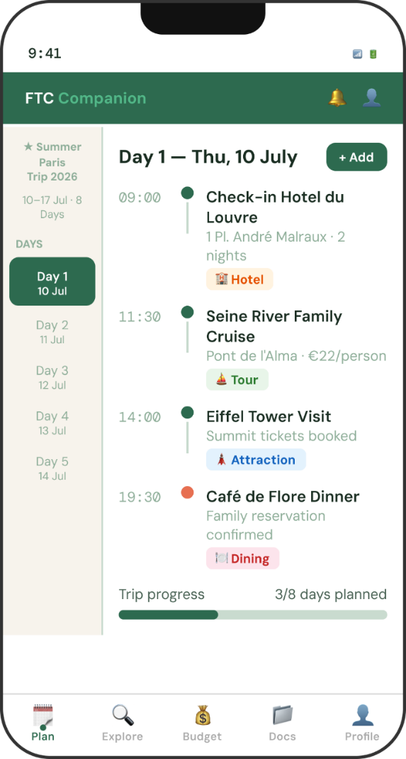

DESIGN RATIONALE:
Chosen Design C: Sidebar + Timeline
Design C was selected over the accordion list (A) and tab carousel (B) for three core reasons rooted in usability and the specific context of family trip planning. The persistent sidebar navigation solves one of the most common pain points in multi-day itinerary management: orientation. Families frequently need to compare what they are doing across days checking whether Day 3 is too packed before adding an activity to Day 2. The sidebar makes all days visible simultaneously without requiring navigation, directly supporting this cognitive task that Designs A and B force users to perform mentally.

The vertical timeline on the right panel mirrors the mental model of a physical diary or calendar a familiar metaphor that reduces the learning curve for non-technical family members including older children and grandparents who may be co-planning. Each activity card has colored edges on the left that are color-coded to represent categories (sightseeing dining culture), so users will be able to understand the layout of the day visually with just a glance and without having to read each label - which is one of the concepts of pre-attentive processing (Ware, 2004).

Emotionally, the calm, organization, and nature vibes that the teal and green colours evoke were the main reasons this colour palette was selected for this particular feature a trip-planning tool. A dashed "Add Activity" card always appears at the end of each day and it offers a continuous clue to capability without being the most noticeable element in the visual field. This respects the hierarchy: existing content reads first; new additions are invited but not forced. The high-fidelity design extends the wireframe concept with typographic hierarchy, time labels, category badges, and cost indicators, giving families an immediate sense of their day's shape and spend.
Feature 2: Destination & Activity Search-S3
Individual- Mofojjul Ali (20042291)

3Up Wireframe Exploration
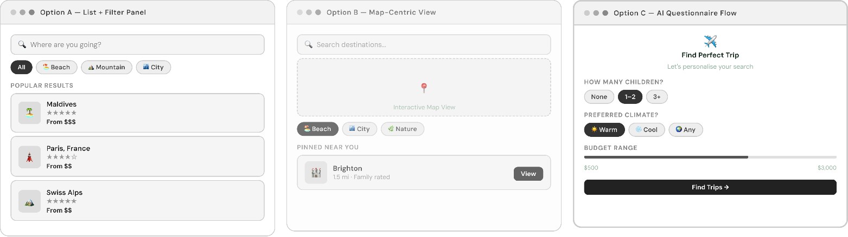
High-Fidelity Design
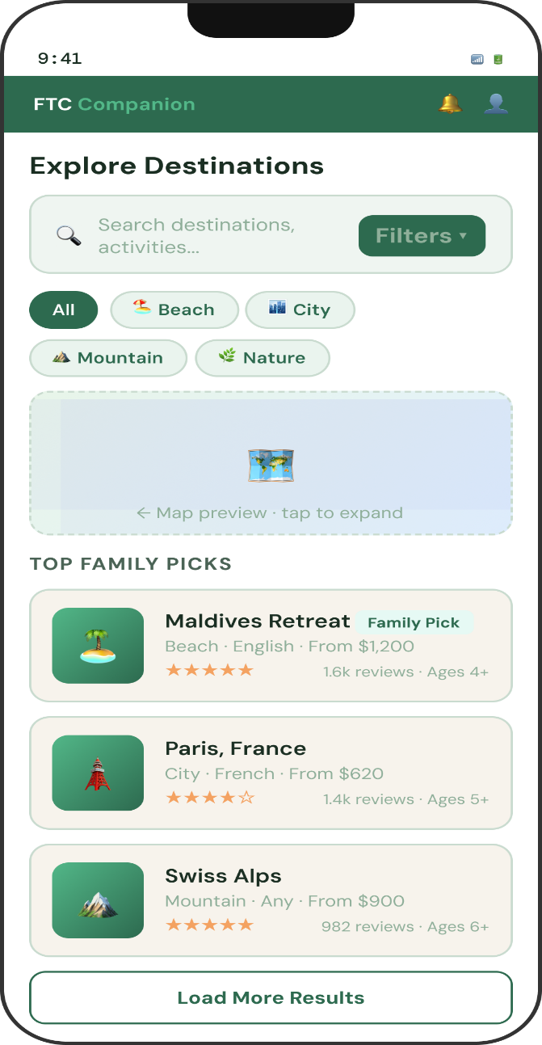

DESIGN RATIONALE:
Chosen design B: map-centric view
Design B was chosen because geographical context is the single most important dimension in travel activity search. When families ask "what can we do?", they are always implicitly asking "what can we do nearby?" a spatial question. A filter list (Design A) strips geography entirely, forcing users to mentally reconstruct spatial relationships from text addresses. A card grid (Design C) suffers the same problem. The map-first design layout helps users recognize distance, grouping, and local relationships right away, which not only lessens mental effort but also makes it easier to come to good decisions.

The arrangement of the layout shows the highly interactive map taking up the main vertical space, with search and filter operations on top and a line of result samples below that can be scrolled horizontally. Such an ordering perfectly matches the natural search pipeline of a user: first set the scene (search bar and category filters), then get the spatial bearing (map), and finally choose among the alternatives (result cards).
Different coloured pointers are used on the map to indicate the status of accommodation (red) versus experiences (green), so that families are able to quickly see how many and what types of options are available in that area.
The result cards below the map are purposely small. They show only picture rating family-friendliness badge, and one "Add to day" CTA. This way, it is not only a less effort for families to make a decision, but also their top requirements are mainly made visible. The blue color theme bases the explorative and discovery moods and contrasts with the teal of the itinerary management; through these two colors, each feature maintains a consistent color identity within the app's design system. Filter chips at the top allow rapid category narrowing without leaving the map context.

Feature 3: Accommodation Listings-S6
Individual- Labiba Ahmed Nowshin (20028401)

3Up Wireframe Exploration
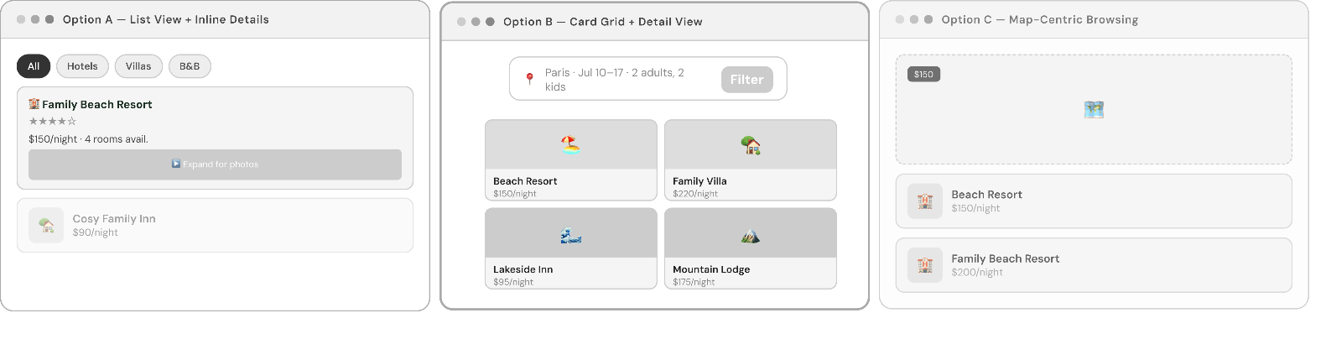

High-Fidelity Design
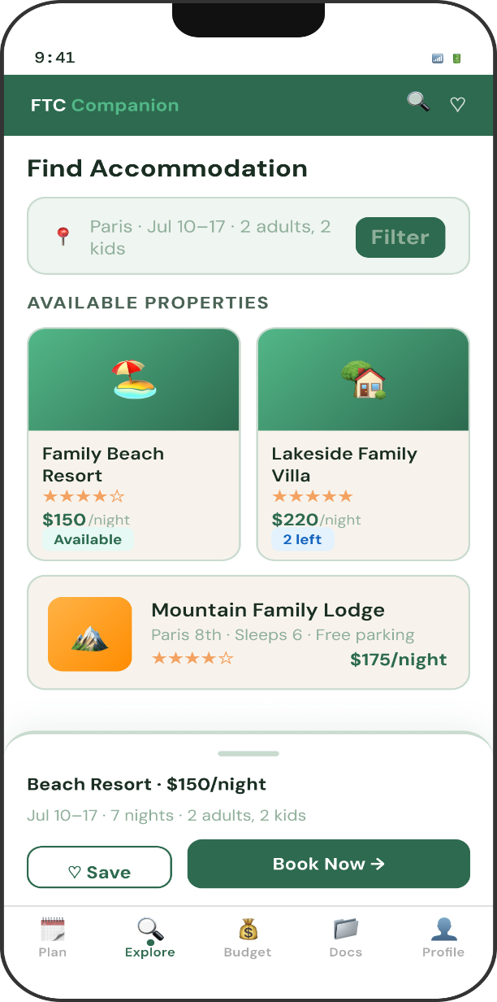

DESIGN RATIONALE:
Chosen Design B: Card Grid + Detail View
Accommodation browsing was done using the card grid layout (Design B) as it maximises the amount of information that can be shown at the same time without making the page less attractive, in fact, these two features are so opposite to the list view (A) and the full-hero detail view (C) that their comparison is almost like night and day. While searching accommodation families are performing a comparative task: they need to scan multiple options across a set of shared dimensions (price rating location). The grid shows four choices at the same time on a single screen allowing quick parallel comparison having no need for the user to keep switching back and forth between different screens as Design C does.
Each card has a main image that depicts the hero (essential for accommodation decision where charm and setting matter emotionally), the title of the property, the area, the number of stars, an indicator if the place is family-friendly, and the price at night. This information architecture satisfies the primary decision signals within a compact card footprint. The featured card receives a highlighted border and stronger typography to communicate "best match", guiding users without removing their agency.

Design A's list view was rejected because it dedicates too much horizontal space to the thumbnail, leaving insufficient room for key details on a mobile screen. Design C's single-hero view fails the comparison task entirely users must navigate away to see another option. The card grid solves both problems. The teal colour system carries through from the itinerary feature, maintaining visual coherence across the app. Future iterations could allow users to swipe cards to a shortlist, building on this foundation.

Feature 4: Trip Budget Management -S5
Individual- Shafema Alam Shithy (20032483)

3Up Wireframe Exploration
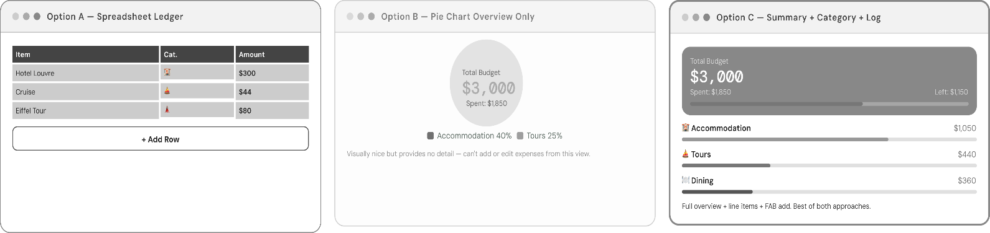

High-Fidelity Design
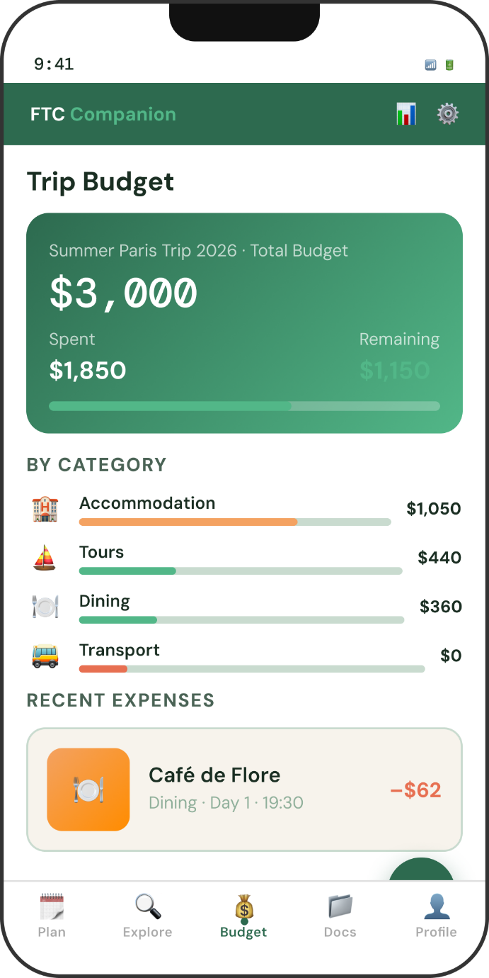

DESIGN RATIONALE:
Chosen Design C: Summary +Category + Log
Design C was selected because budget management is a layered task that requires both macro awareness (how much have we spent overall?) and micro visibility (what did we spend it on?). The three-tier layout summary strip, category breakdown, expense log directly maps to these three levels of financial awareness. No other design provides all three without requiring navigation.

The donut chart in Design B visualises distribution elegantly but sacrifices the expense log, leaving users without a transaction trail to verify or recall what was booked. Design A's simple progress bar and log provides the log but lacks categorical insight, making it impossible to understand which areas of the trip are overspending. Design C resolves both gaps in a single, scrollable screen.

The amber and warm gold color scheme expresses financial literacy without any stressaware but still calm. The horizontal progress indicator is designed in two colours (amber filled on gold background) for easy understanding even by colour-blind users, additionally highlighted by a numeric label. Items on the category list get the different left-border colours teal for activities, blue for transport, amber for accommodation which makes the whole thing easily readable without having to look at the labels, a big plus for families who are reviewing budgets after a busy day of traveling. The "Add Expense" button helps to keep the spend log updated as the expenditures happen, supported by accuracy through an easy, instant recording.

Feature 5: Travel Document Upload-S28
Individual- Shajid Ahmed (20026266)

3Up Wireframe Exploration
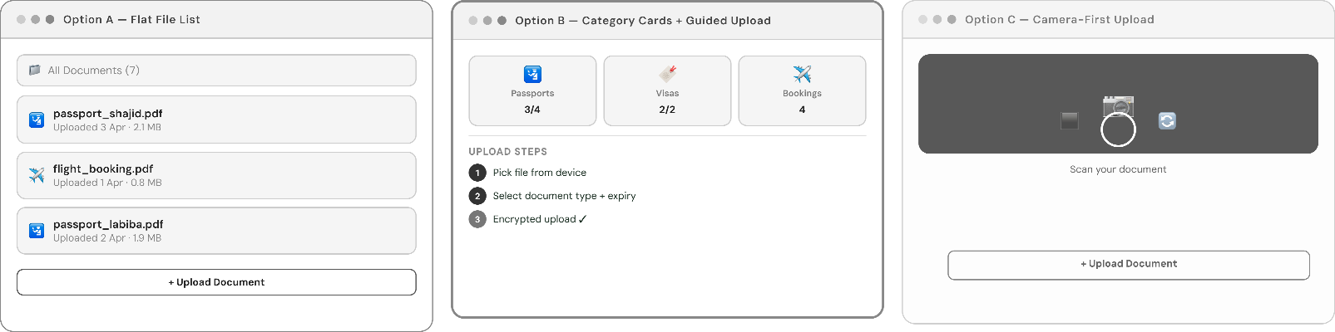

High-Fidelity Design
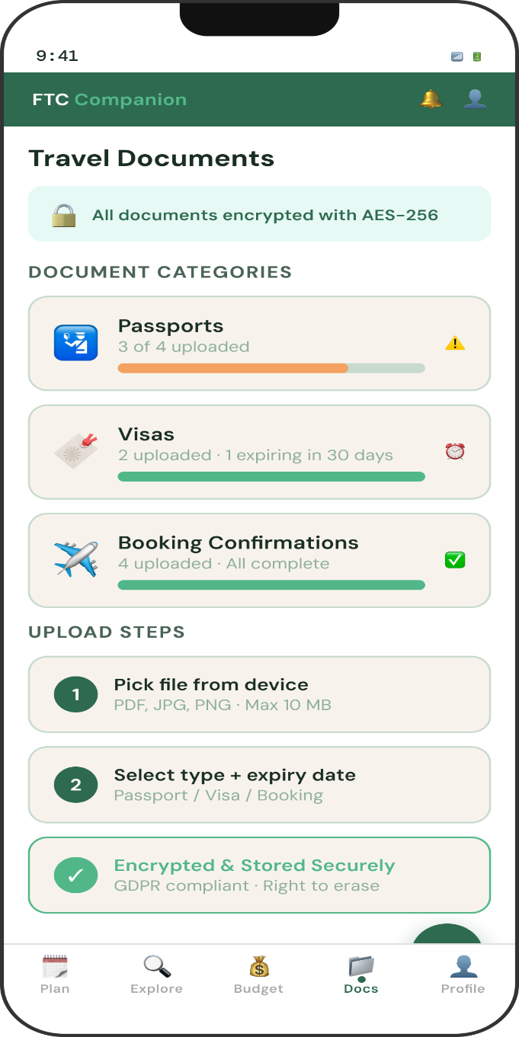
DESIGN RATIONALE:
Chosen Design B: Category Cards + Guided Upload
Travel documents are some of the most sensitive assets a family carries with them. Passports, visas, and booking confirmations are not only a representation of one's legal identity but also a financial commitment. So, in designing this feature, the first consideration should be the clarity of the organisation and the communication of security. Design B achieves this through a category-first architecture: users see four document types (Passports, Visas, Bookings, Insurance) as distinct card tiles, each with a completion indicator showing upload progress. This immediately answers the critical question families ask: "Have I uploaded everything I need?"

The drop-zone approach in Design A is too abstract it provides no structure for what should be uploaded or in what grouping. Families with four members need to track eight passports; without categories, the flat list becomes unmanageable. Design C's tab segmentation is better but requires navigation between categories, preventing the at-a-glance overview that Design B provides on a single screen.

The purple palette was chosen for this feature specifically because purple is the least used colour in the wider app palette, making the document vault feel distinct and reinforcing the "secure vault" metaphor through visual differentiation. The security credentials (AES-256, GDPR compliant) are surfaced in the header not as boastful features but as reassurance for a feature asking users to upload passport scans, trust signals must be prominent and immediate. The upload CTA is context-aware: it reflects the last-touched category, reducing the cognitive overhead of re-selecting document type on each upload session. The mini progress bars on each card gamify completion in a gentle, motivating way.

Feature 6: Digital Photo Album-S29
Individual- Washif Hasan Piyal (20035321)

3Up Wireframe Exploration
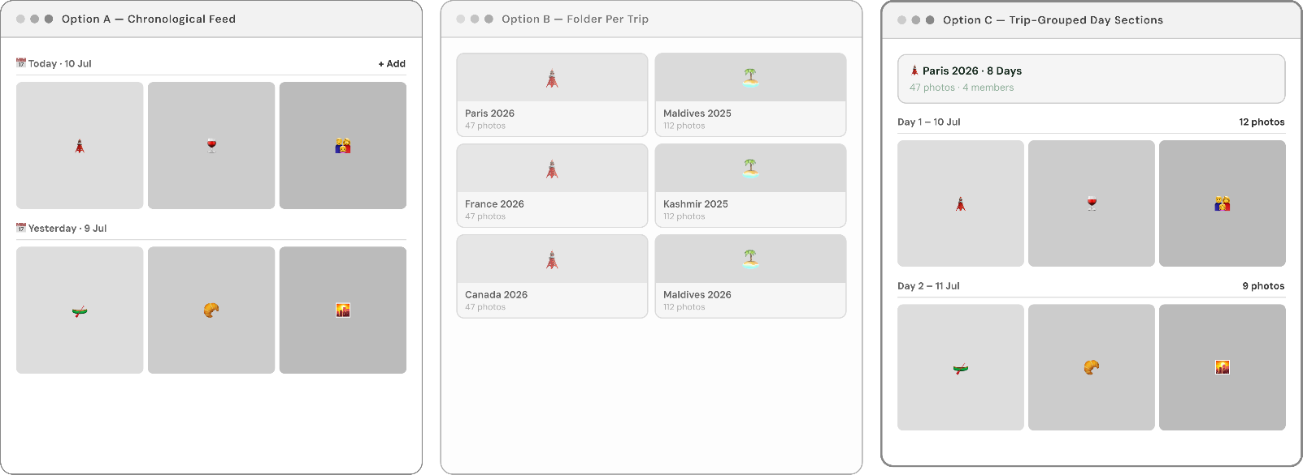

High-Fidelity Design
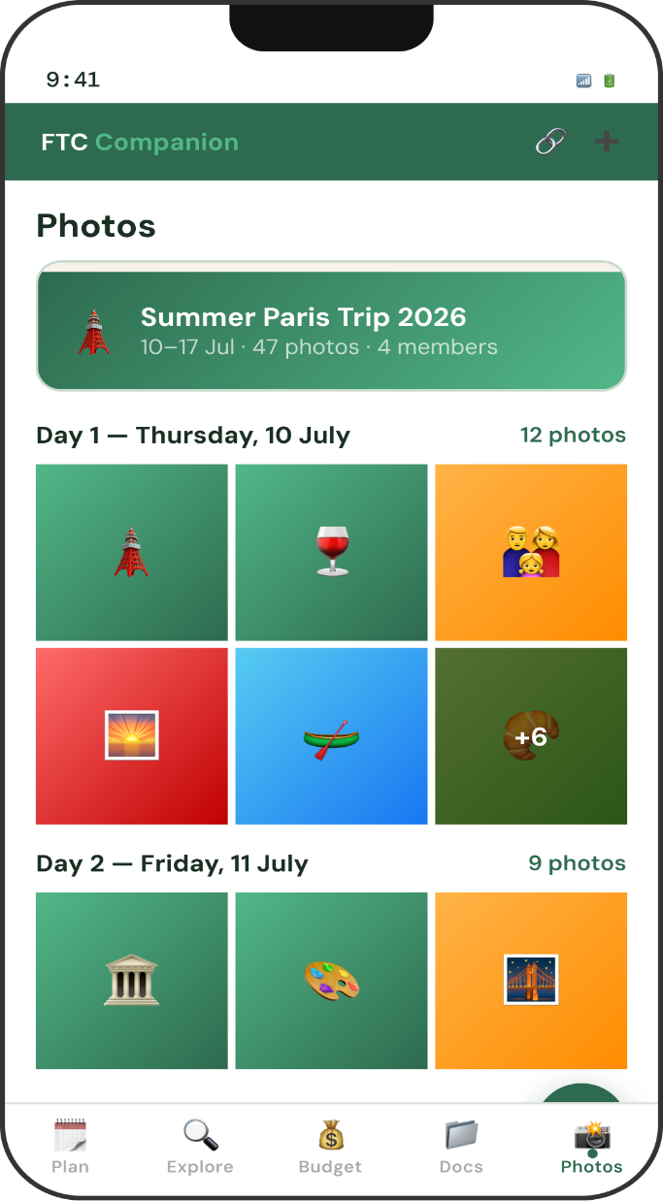
DESIGN RATIONALE:
Chosen Design C: Trip-Grouped Day Sections
Families, when looking back at their vacations, tend to remember in terms of days or events "What was it that we did on the third day?" rather than by the time the photos were taken or by viewing the pictures in a simple grid. The way Design C has divided the album into day-grouped sections is really in line with this way of thinking, and it gives the album the look and feel of a travel diary that is nicely organized rather than just a plain camera roll.

Design A's flat grid (like a native camera gallery) provides no narrative context it cannot answer "which photos are from the Louvre?" without manual search. Design B's hero and filmstrip are visually stunning for one memory only but cannot handle the multi-day album use case where dozens of days need to be accessible. Design C fixes this problem by giving each day a named, collapsible section along with a mini mosaic preview, so that families can get an overview of the whole trip's memories on a single scrollable screen.

The coral and warm terracotta color scheme was chosen for this highlight to raise the sentiments of warmth, nostalgia, and joy typically linked to travel memories. This is the most emotionally expressive element in the application and its design language is a reflection of that. The "+15" overflow indicator on Day 2 communicates richness of content without crowding the preview, while the "View all" link provides a clear path to the full day's gallery. The photo upload CTA at the base is warm and inviting, reinforcing the album's collaborative, family-centred nature.

6. Development Tasks
Twelve development tasks are defined below, drawn from four user stories: S2 (Create Multi-Day Itinerary), S6 (List Accommodation), S28 (Upload Travel Documents), and S21 (Offer Travel Perks). Tasks are specified with unique identifiers, sizing (Small / Medium / Large), inter-task dependencies, and a checklist of technical subtasks. Each development task corresponds to an implementable unit of work assignable to one developer within a two-week sprint.

- Development Tasks for Story ID: S2 – Create Multi-Day Itinerary

Task ID: T1 | Task name: Design and implement Itinerary database schema
Task size | Medium
Dependencies | None
Checklist of subtasks | - Create a relational database schema for the Itinerary entity using MySQL or PostgreSQL.  - Define primary key ItineraryID (UUID), foreign key UserID, trip_name (VARCHAR), start_date (DATE), end_date (DATE), created_at (TIMESTAMP).  - Create the ItineraryDay child table with DayID, ItineraryID (FK), day_number, and date columns.  - Write database migration scripts using Flyway or Liquibase.  - Ensure Third Normal Form (3NF) compliance.  - Create indexes on UserID and start_date for query optimisation.

Task ID: T2 | Task name: Build Itinerary creation API endpoint (POST /itineraries)
Task size | Medium
Dependencies | T1
Checklist of subtasks | - Implement POST /api/v1/itineraries RESTful endpoint using Node.js/Express or Django REST Framework.  - Apply input validation: trip name (max 100 chars), start_date < end_date, trip duration <= 30 days.  - Return 422 Unprocessable Entity with field-level error messages for validation failures.  - Persist validated itinerary to the database and return 201 Created with the new ItineraryID.  - Write unit tests for validation logic achieving >= 90% branch coverage.  - Secure endpoint with JWT authentication middleware.

Task ID: T3 | Task name: Implement itinerary day view and activity slots (frontend)
Task size | Large
Dependencies | T1, T2
Checklist of subtasks | - Build React/React Native component ItineraryView rendering collapsible day panels.  - Fetch itinerary data from GET /api/v1/itineraries/:id on component mount.  - Render each day card with date label, day number, and an Add Activity floating action button.  - Implement skeleton loading state while API response is pending.  - Support offline cached read-only view using React Query or SWR with stale-while-revalidate strategy.  - Write Cypress or Detox end-to-end tests for itinerary creation flow.

- Development Tasks for Story ID: S6 – List Accommodation with Photos and Prices

Task ID: T4 | Task name: Create Listing database schema and photo storage integration
Task size | Medium
Dependencies | None
Checklist of subtasks | - Design relational schema for Listing table: ListingID (UUID), BusinessID (FK), title, description, price_per_night (DECIMAL), status (ENUM: pending, approved, rejected), created_at.  - Create ListingPhoto table: PhotoID, ListingID (FK), file_path (VARCHAR), sort_order (INT).  - Integrate AWS S3 or Azure Blob Storage for photo file storage; store S3 object keys in file_path column.  - Configure pre-signed URL generation for serving photos securely.  - Ensure Third Normal Form (3NF) compliance.  - Create composite index on (ListingID, sort_order) for efficient photo retrieval.

Task ID: T5 | Task name: Build listing creation and photo upload API
Task size | Medium
Dependencies | T4
Checklist of subtasks | - Implement POST /api/v1/listings endpoint accepting multipart/form-data with listing details and up to 20 photos.  - Validate minimum 3 photos uploaded; return 422 with error message if fewer than 3 are provided.  - Upload photos to S3 asynchronously; return 202 Accepted immediately and update listing status via webhook.  - Implement PATCH /api/v1/listings/:id for price edits; apply warning logic if confirmed bookings exist.  - Protect endpoints with business-role JWT middleware; only verified business accounts may create listings.  - Write integration tests covering happy path, insufficient photos, and price edit with bookings scenarios.

Task ID: T6 | Task name: Build listing browse and detail screens (frontend)
Task size | Large
Dependencies | T4, T5
Checklist of subtasks | - Build ListingCard component displaying hero thumbnail, title, price, and star rating.  - Implement ListingDetailScreen with full-screen photo carousel (react-native-snap-carousel or Swiper.js).  - Fetch listings from GET /api/v1/listings with query params for location, price_min, price_max, dates.  - Implement infinite scroll pagination on the listings browse screen.  - Add sticky booking bar at bottom of detail screen with Book Now CTA.  - Write unit tests for ListingCard and snapshot tests for ListingDetailScreen.

- Development Tasks for Story ID: S28 – Upload Travel Documents

Task ID: T7 | Task name: Design encrypted document storage architecture
Task size | Large
Dependencies | None
Checklist of subtasks | - Evaluate AWS S3 with KMS server-side encryption (SSE-KMS) vs client-side AES-256 pre-upload encryption.  - Implement SSE-KMS as primary strategy: configure S3 bucket with KMS key, enforce encryption in bucket policy.  - Create TravelDocument database table: DocumentID (UUID), UserID (FK), document_type (ENUM: passport, visa, booking), file_name, s3_key, uploaded_at, expiry_date.  - Implement pre-signed URL generation with 15-minute expiry for secure document retrieval.  - Document GDPR compliance measures: right to erasure endpoint (DELETE /api/v1/documents/:id removes S3 object and DB record), data retention policy.  - Conduct threat modelling session using STRIDE methodology.

Task ID: T8 | Task name: Build document upload and retrieval API
Task size | Medium
Dependencies | T7
Checklist of subtasks | - Implement POST /api/v1/documents endpoint accepting multipart/form-data with document_type and file.  - Validate file types: accept PDF, JPG, PNG only; reject other MIME types with 415 Unsupported Media Type.  - Validate file size: maximum 10 MB per document.  - Stream file directly to S3 using pre-signed upload URL to avoid storing files on the application server.  - Implement GET /api/v1/documents to list user's documents and GET /api/v1/documents/:id/download to return a time-limited pre-signed download URL.  - Write unit and integration tests; include penetration testing checklist for OWASP Top 10 file upload vulnerabilities.

Task ID: T9 | Task name: Build document management UI (frontend)
Task size | Medium
Dependencies | T7, T8
Checklist of subtasks | - Build DocumentCategoryScreen with cards for Passports, Visas, and Bookings, each showing document count and upload status indicator.  - Implement DocumentUploadFlow: file picker (react-native-document-picker) -> type selection -> upload progress bar -> success confirmation.  - Display upload progress using Axios upload progress callbacks.  - Implement document deletion with confirmation modal; call DELETE /api/v1/documents/:id on confirmation.  - Cache document list locally using AsyncStorage for offline read-only access.  - Write Detox or Cypress E2E tests for the full upload and delete flow.

- Development Tasks for Story ID: S21 – Offer Travel Perks and Discounts

Task ID: T10 | Task name: Design discount offer database schema
Task size | Small
Dependencies | None
Checklist of subtasks | - Create DiscountOffer table: OfferID (UUID), PartnerID (FK), offer_name, discount_type (ENUM: percentage, fixed), discount_value (DECIMAL), valid_from (DATE), valid_to (DATE), eligible_departments (JSON), status (ENUM: active, expired, draft).  - Create OfferRedemption table: RedemptionID, OfferID (FK), EmployeeID (FK), redeemed_at (TIMESTAMP), booking_reference.  - Add database-level CHECK constraint ensuring valid_to >= valid_from.  - Create index on (OfferID, status) for efficient active offer lookups.  - Ensure 3NF compliance.

Task ID: T11 | Task name: Build discount offer creation and redemption API
Task size | Medium
Dependencies | T10
Checklist of subtasks | - Implement POST /api/v1/offers endpoint for corporate partners to create discount offers.  - Validate date range: return 422 if valid_to < valid_from.  - Implement POST /api/v1/offers/:id/redeem endpoint: check offer status is active, valid_to >= today, and OfferID not already redeemed by this EmployeeID.  - Return 409 Conflict with message 'This offer has already been redeemed by your account' for double-redemption attempts.  - Return 410 Gone with expiry date message if offer has expired.  - Trigger email notification to all eligible employees on offer creation via SendGrid.

Task ID: T12 | Task name: Build corporate partner dashboard and employee perk redemption UI
Task size | Large
Dependencies | T10, T11
Checklist of subtasks | - Build PartnerDashboard screen with active offer list, redemption count per offer, and department breakdown chart (Chart.js or Recharts).  - Implement CreateOfferForm with validation: offer name, discount type selector, date range picker (enforcing valid_to >= valid_from on client side), department multi-select.  - Build EmployeePerksScreen showing available, redeemed, and expired offers with visual status badges.  - Implement RedeemOfferFlow: review offer details -> confirm redemption -> display success confirmation with booking reference.  - Display expired offers with greyed-out styling and expiry date message.  - Write unit tests for date validation logic and snapshot tests for PartnerDashboard.

7. Test Cases
Thirty test cases are defined below for ten user stories selected from the Family Travel Companion backlog. The ten user stories tested are: S2, S6, S10, S14, S17, S21, S24, S28, S29, S30.
Team Test Case:
- User Story S2: Create Multi-Day Itinerary

Test Case ID: TC1
Test Description: Successfully create a new multi-day itinerary
User Story ID: S2 | User Story Title: Create Multi-Day Itinerary
Step ID | Step Description | Test Data | Expected Result
1 | Launch the app, log in with valid credentials, and navigate to the My Trips dashboard. | Username: testfamily@email.com, Password: Test@1234 | User is successfully logged in and the My Trips dashboard is displayed.
2 | Click the 'Create New Itinerary' button and enter the trip name and date range in the form. | Trip name: Summer Paris Trip 2026, Start: 2026-07-10, End: 2026-07-17 | Form fields accept input; system calculates 8 days and displays the count.
3 | Click 'Create Itinerary' and verify the new itinerary is created with the correct day panels. |  | User is redirected to the itinerary view showing Days 1–8. Toast notification: 'Itinerary created successfully'.

Test Case ID: TC2
Test Description: Attempt to create itinerary with end date before start date
User Story ID: S2 | User Story Title: Create Multi-Day Itinerary
Step ID | Step Description | Test Data | Expected Result
1 | Log in and navigate to the Create New Itinerary form. | Valid user credentials | Create New Itinerary form is displayed.
2 | Enter a trip name and set an end date that is earlier than the start date. | Trip name: Invalid Trip, Start: 2026-07-10, End: 2026-07-05 | Both date fields are populated; no immediate error shown.
3 | Click 'Create Itinerary' and verify that the form fails validation and displays an error. |  | Form does not submit. Inline error: 'End date cannot be before start date'. Trip name and dates remain visible in the form.

Test Case ID: TC3
Test Description: Attempt to create itinerary exceeding the 30-day maximum duration
User Story ID: S2 | User Story Title: Create Multi-Day Itinerary
Step ID | Step Description | Test Data | Expected Result
1 | Log in and open the Create New Itinerary form. | Valid user credentials | Create New Itinerary form is displayed.
2 | Enter a trip spanning more than 30 days in the start and end date fields. | Trip name: Long Trip, Start: 2026-07-01, End: 2026-08-01 (32 days) | Fields are populated without immediate error.
3 | Click 'Create Itinerary' and verify the system rejects the request and provides guidance. |  | Error displayed: 'The trip cannot last more than 30 days.' System suggests splitting into two itineraries. No itinerary is created.

- User Story S6: List Accommodation with Photos and Prices
Test Case ID: TC4
Test Description: Successfully create a complete accommodation listing
User Story ID: S6 | User Story Title: List Accommodation with Photos and Prices
Step ID | Step Description | Test Data | Expected Result
1 | Log in as a verified hotel owner and navigate to the Manage Listings section. | Business account: hotelowner@familyresort.com | Business dashboard is displayed with Manage Listings section visible.
2 | Click 'Add New Listing', complete all required fields, and upload 5 property photos. | Name: Family Beach Resort, Price: $150/night, 5 JPG files each <5 MB | All fields accept input; photos are uploaded and previewed in the form.
3 | Click 'Submit Listing for Review' and verify the listing is saved with the correct status. |  | Listing saved with status 'Pending Approval'. Success message: 'Listing submitted for review'.

Test Case ID: TC5
Test Description: Attempt to create listing without the minimum required photos
User Story ID: S6 | User Story Title: List Accommodation with Photos and Prices
Step ID | Step Description | Test Data | Expected Result
1 | Log in as a verified hotel owner and open the Add New Listing form. | Verified business credentials | Listing creation form is displayed.
2 | Complete all text fields but upload only 1 photo instead of the required minimum of 3. | Title: Cosy Family Inn, 1 JPG uploaded | Text fields are populated; one photo thumbnail is visible.
3 | Click 'Submit Listing for Review' and verify that the system blocks submission with a validation error. |  | Validation error: 'Please upload at least 3 photos of your property.' Listing is not submitted; title and description remain in the form.

Test Case ID: TC6
Test Description: Edit listing price where confirmed bookings already exist
User Story ID: S6 | User Story Title: List Accommodation with Photos and Prices
Step ID | Step Description | Test Data | Expected Result
1 | Log in as a business owner with an approved listing that has existing confirmed bookings. | Listing: Family Beach Resort, 10 confirmed bookings at $150/night | Listing management page displays current price as $150.
2 | Edit the price field to a new value and click 'Save Changes'. | New price: $180/night | A warning modal appears: 'Existing bookings will remain at the original price. Only future bookings will be charged $180.'
3 | Confirm the price change and verify that existing bookings are unaffected. | Click 'Confirm' on the warning modal | Price updated to $180 for future bookings. All 10 existing bookings remain at $150/night in the booking records.

- User Story S10: List Tour with Description and Pricing

Test Case ID: TC7
Test Description: Successfully create and publish a new tour listing
User Story ID: S10 | User Story Title: List Tour with Description and Pricing
Step ID | Step Description | Test Data | Expected Result
1 | Log in as a verified local experience host and navigate to the My Experiences dashboard. | Host account: localhost@tourcompany.com | My Experiences dashboard is displayed with 'Create New Experience' button.
2 | Click 'Create New Experience', complete all required fields, and upload 4 tour photos. | Title: Secret Food Tour of Old Town, Duration: 3 hours, Price: $45/person, 4 JPG files <5 MB each | All fields populated; photos displayed as thumbnails. No validation errors shown.
3 | Click 'Publish' and verify the tour listing is live and visible to travellers. |  | Tour listing is saved and published. Success message: 'Your experience is now live.'

Test Case ID: TC8
Test Description: Attempt to publish a tour listing with the price field empty
User Story ID: S10 | User Story Title: List Tour with Description and Pricing
Step ID | Step Description | Test Data | Expected Result
1 | Log in as a verified host and open the Create New Experience form. | Verified host credentials | Create New Experience form is displayed.
2 | Enter the tour title and description but leave the price field completely blank. | Title: City Art Walk, Description: Explore street murals, Price: (empty) | Title and description fields are populated; price field is blank.
3 | Click 'Publish' and verify that the system prevents submission with a validation error. |  | Validation error: 'Price is required. Please enter a valid amount.' Listing is not published; title and description remain visible.

Test Case ID: TC9
Test Description: Duplicate listing title detection when same title already exists
User Story ID: S10 | User Story Title: List Tour with Description and Pricing
Step ID | Step Description | Test Data | Expected Result
1 | Log in as a host who already has an active listing and open the Create New Experience form. | Existing listing: Secret Food Tour of Old Town (status: Active) | My Experiences shows existing active listing; Create New Experience form opens.
2 | Enter an identical title to the existing active listing in the new listing form. | New listing title: Secret Food Tour of Old Town | All fields are populated; no immediate warning shown until submission.
3 | Click 'Publish' and verify the system detects the duplicate and offers an alternative title. |  | Warning: 'You already have a listing with this title.' System suggests 'Secret Food Tour of Old Town (2)'. Listing publishes successfully with the suggested title.

- User Story S14: Coordinate Group Trips for Students

Test Case ID: TC10
Test Description Successfully create a group trip for a student community
User Story ID: S14 | User Story Title: Coordinate Group Trips for Students
Step ID | Step Description | Test Data | Expected Result
1 | Log in as an educational organisation administrator and navigate to the Manage Group Trips section. | Account: admin@greenwoodschool.edu | Organisation dashboard is displayed with Manage Group Trips section visible.
2 | Click 'Create Group Trip', enter all required trip details, and add three timed itinerary stops. | Trip: Year 10 History Trip – London, Date: 2026-05-15, Group: 45 students; Stops: British Museum (09:00), Natural History Museum (13:00), Depart (17:00) | All fields accept input; stops appear in chronological order on the trip schedule view.
3 | Click 'Save Trip' and verify the group trip is saved and appears in the organisation's trip list. |  | Success message: 'Group trip created successfully'. Trip appears in the organisation's trip list with all details intact.

Test Case ID: TC11
Test Description: Attempt to create group trip with participant count exceeding venue capacity
User Story ID: S14 | User Story Title: Coordinate Group Trips for Students
Step ID | Step Description | Test Data | Expected Result
1 | Log in as organisation admin and open the Create Group Trip form. | Verified org admin credentials | Create Group Trip form is displayed.
2 | Select a venue with a known maximum capacity and enter a group size that exceeds it. | Venue: City Science Museum (max capacity: 30); Group size entered: 60 | Venue and group size fields are populated without immediate validation error.
3 | Click 'Save Trip' and verify the system blocks the save with a capacity warning message. |  | Warning: 'Your group size (60) exceeds this venue's maximum capacity (30). Please reduce group size or select a different venue.' Trip is not saved.

Test Case ID: TC12
Test Description: Generate participant manifest with emergency contacts for chaperones
User Story ID: S14 | User Story Title: Coordinate Group Trips for Students
Step ID | Step Description | Test Data | Expected Result
1 | Log in as org admin and navigate to an existing saved group trip with a full participant list. | Existing trip: Year 10 History Trip – London (45 participants) | Trip detail screen is displayed with participant list and Generate Manifest button visible.
2 | Click 'Generate Participant Manifest' and wait for the system to produce the PDF document. |  | System generates a PDF manifest listing all 45 participants with name, emergency contact name, emergency contact phone, and medical notes.
3 | Download the manifest and share it with the lead chaperone via the Share button. | Chaperone email: chaperon1@greenwoodschool.edu | PDF downloads successfully with trip date and trip name as header. Chaperone receives email with manifest attached within 1 minute.

- User story S17- Share Curated Itineraries for Local Areas

Test Case ID: TC13
Test Description: Tourism board successfully publishes a curated itinerary
User Story ID: S17 | User Story Title: Share Curated Itineraries for Local Areas
Step ID | Step Description | Test Data | Expected Result
1 | Log in as a verified tourism board administrator and navigate to the Create Curated Itinerary form. | Account: admin@visitlondon.gov.uk | Tourism board dashboard is displayed; Create Curated Itinerary form is accessible.
2 | Enter the itinerary title and add three timed attraction stops across Day 1. | Title: 3-Day London Family Adventure; Day 1: Tower of London (09:00–12:00), Tower Bridge (13:00–14:00), South Bank (15:00–18:00) | Itinerary title and stops are entered; stops display on a day-by-day schedule.
3 | Click 'Publish Itinerary' and verify the itinerary is visible to families searching London. |  | Itinerary published and visible in London search results. Success message: 'Curated itinerary published successfully'.

Test Case ID: TC14
Test Description: Family member discovers and adds a curated itinerary to their trip
User Story ID: S17 | User Story Title: Share Curated Itineraries for Local Areas
Step ID | Step Description | Test Data | Expected Result
1 | Log in as a family member and search for London activities for a specific date range. | Search: Location: London, Dates: 2026-08-10 to 2026-08-13 | Search results include curated itineraries alongside individual listings.
2 | Open the '3-Day London Family Adventure' curated itinerary and review its stops and costs. |  | Itinerary detail page shows all stops, map view, and estimated costs per day.
3 | Click 'Add to My Trip' and verify that all stops are copied into the family member's selected trip. | Target trip: Our London Holiday 2026 | All 9 stops (3 per day) are copied into the family member's itinerary with correct times and descriptions.

Test Case ID: TC15
Test Description: Tourism board attempts to publish an itinerary with no stops added
User Story ID: S17 | User Story Title: Share Curated Itineraries for Local Areas
Step ID | Step Description | Test Data | Expected Result
1 | Log in as tourism board admin and open the Create Curated Itinerary form. | Verified tourism board credentials | Create Curated Itinerary form is displayed.
2 | Enter the itinerary title and description but add no attraction stops. | Title: Empty Weekend Guide, Description: Coming soon | Title and description fields are populated; no stops have been added.
3 | Click 'Publish Itinerary' and verify the system blocks publication with a validation error. |  | Validation error: 'Please add at least one attraction stop before publishing.' Itinerary is not published.

Individual Test Case: Shafema Alam Shithy (20032483)

- User Story-S21-Offer Travel Perks and Discounts to Employees

Test Case ID: TC16
Test Description: Corporate partner successfully creates and publishes a discount offer
User Story ID: S21 | User Story Title: Offer Travel Perks and Discounts to Employees
Step ID | Step Description | Test Data | Expected Result
1 | Log in as a corporate partner administrator and navigate to the Employee Benefits dashboard. | Account: admin@techcorp.com | Employee Benefits dashboard is displayed with 'Create Offer' button visible.
2 | Click 'Create Offer', complete all required fields including offer name, discount, and validity dates. | Offer: Summer Holiday 15% Discount, Discount: 15%, Valid: 2026-06-01 to 2026-08-31, Departments: All | All fields populated without validation errors. Offer preview is shown.
3 | Click 'Publish' and verify the offer is active and visible to eligible employees. | Log in as employee1@techcorp.com to verify | Offer status: Active. Confirmation: 'Offer published'. Employee sees the offer in Available Offers with expiry date 2026-08-31.

Test Case ID: TC17
Test Description: Attempt to create offer with invalid date range (end date before start)
User Story ID: S21 | User Story Title: Offer Travel Perks and Discounts to Employees
Step ID | Step Description | Test Data | Expected Result
1 | Log in as corporate partner admin and open the Create Offer form. | Verified corporate partner credentials | Create Offer form is displayed.
2 | Enter offer details with an end date that precedes the start date. | Offer: Spring Deal, Valid from: 2026-05-01, Valid to: 2026-04-30 | Fields populated; date conflict is not immediately flagged.
3 | Click 'Publish' and verify the system rejects the offer with an appropriate validation error. |  | Validation error: 'End date cannot be before start date.' Offer is not created. No new offer appears in the Active Offers list.

Test Case ID: TC18
Test Description: Employee attempts to redeem an expired discount offer
User Story ID: S21 | User Story Title: Offer Travel Perks and Discounts to Employees
Step ID | Step Description | Test Data | Expected Result
1 | Log in as an employee and navigate to the Employee Perks screen to locate an expired offer. | Employee: employee2@techcorp.com; Expired offer: Winter Getaway 10% Discount (expired 2026-03-31) | Employee Perks screen displays the expired offer in the 'Expired' section with a greyed-out badge.
2 | lick 'Apply Discount' on the expired offer during checkout. | Booking total: $500 | System prevents redemption and returns an error message with the expiry date.
3 | Verify that the checkout total is unaffected and the discount was not applied. |  | Error: 'This offer expired on 2026-03-31. Please select an active offer.' Checkout total remains $500 with no discount applied.

Individual Test Case: Labiba Ahmed Nowshin (20028401)

- User Story-S24-Verify and Approve Business Accounts

Test Case ID: TC19
Test Description: Platform administrator successfully approves a business account
User Story ID: S24 | User Story Title: Verify and Approve Business Accounts
Step ID | Step Description | Test Data | Expected Result
1 | Log in as a platform administrator and open the pending business applications queue. | Admin: platformadmin@familytravel.com | Admin dashboard is displayed showing the pending applications queue.
2 | Open the pending application for 'Coastal Surf School' and review the uploaded documents inline. | Application ID: APP-00234; Documents: Business licence (PDF), Insurance certificate (PDF) | Application detail screen shows uploaded documents; admin can view PDFs inline without downloading.
3 | Click 'Approve Application' and verify that the business owner receives the approval notification. |  | Application status changes to 'Approved'. Business owner receives email: 'Your account has been approved. You may now create listings.'

Test Case ID: TC20
Test Description: Administrator rejects a business account with incomplete documentation
User Story ID: S24 | User Story Title: Verify and Approve Business Accounts
Step ID | Step Description | Test Data | Expected Result
1 | Confirm the missing document by reviewing the application detail screen. |  | Application detail shows only the business licence uploaded; the insurance certificate field is empty.
2 | Click 'Reject Application', enter a rejection reason, and confirm. | Reason: Insurance certificate not provided. Required for all tour operators. | Rejection is confirmed. Application status changes to 'Rejected'. Business owner receives the rejection email with the stated reason.
3 | Attempt to create a listing from the rejected business account to verify access is blocked. | Log in as Riverside Tours Ltd account | 'Create Listing' button is disabled. Tooltip reads: 'Account not yet approved'.

Test Case ID: TC21
Test Description: Administrator requests additional information from an applicant with illegible documents
User Story ID: S24 | User Story Title: Verify and Approve Business Accounts
Step ID | Step Description | Test Data | Expected Result
1 | Click 'Request More Information' and enter a specific resubmission request in the message field. | Message: Please resubmit your business registration certificate the uploaded file is illegible. | Message field accepts the input; the Send Request button becomes active.
2 | Click 'Send Request' and verify the application status is updated. |  | Application status changes to 'Awaiting Information'. Business owner receives an email with the specific resubmission request.
3 | Attempt to create a listing from the applicant's account to verify access remains restricted. | Log in as Sunshine Family Bungalows account | Listing creation is disabled with message: 'Your application is under review'.

Individual Test Case: Shajid Ahmed (20026266)

- User Story- S28 — Upload and Store Travel Documents

Test Case ID: TC22
Test Description: Family member successfully uploads a passport document
User Story ID: S28 | User Story Title: Upload and Store Travel Documents
Step ID | Step Description | Test Data | Expected Result
1 | Tap the Passports category card to open the category upload view. |  | Passports category view opens, displaying existing documents and the 'Upload Document' button.
2 | Click 'Upload Document', select a valid passport PDF from the file picker, and wait for the upload to complete. | File: passport_scan.pdf, Size: 2.4 MB, Type: PDF | Upload progress bar is displayed. Upload completes within 10 seconds.
3 | Verify the document is listed in the Passports category and is accessible via the view link. |  | Document appears with filename and upload date. Success: 'Document uploaded securely'. Tapping 'View Document' opens the PDF via a pre-signed URL.

Test Case ID: TC23
Test Description: System prevents upload of an unsupported file type
User Story ID: S28 | User Story Title: Upload and Store Travel Documents
Step ID | Step Description | Test Data | Expected Result
1 | Open the file picker and attempt to select a file with an unsupported extension. | File: visa_scan.exe, Size: 1.1 MB, Type: EXE | File picker enforces filters for PDF, JPG, PNG only. The .exe file is greyed out and cannot be selected.
2 | Attempt to bypass the filter by dragging the .exe file directly onto the upload area. | visa_scan.exe dragged onto upload zone | System rejects the file on the server side and returns a file type error.
3 | Verify the error message and confirm no upload occurred. |  | Error: 'File type not supported. Please upload a PDF, JPG, or PNG file.' No file is stored.

Test Case ID: TC24
Test Description: Family member permanently deletes a stored travel document
User Story ID: S28 | User Story Title: Upload and Store Travel Documents
Step ID | Step Description | Test Data | Expected Result
1 | Tap 'Delete' on the 'booking_confirmation.pdf' document entry. |  | A confirmation modal appears: 'Are you sure you want to permanently delete booking_confirmation.pdf? This action cannot be undone.'
2 | Click 'Delete' on the confirmation modal to confirm the deletion. | Click 'Delete' on modal | Document record is deleted from the database and the file is removed from S3 storage.
3 | Verify the document is removed from the Bookings category view and confirm the pre-signed URL no longer works. | Attempt to access the previous pre-signed URL | Bookings card updates to show 0 documents. The pre-signed URL returns 403/404, confirming permanent removal.

Individual Test Case: Washif Hasan Piyal (20035321)

- User Story S29 - Create Digital Photo Album from Trips

Test Case ID: TC25
Test Description: Family member successfully creates a photo album for a completed trip
User Story ID: S29 | User Story Title: Create Digital Photo Album from Trips
Step ID | Step Description | Test Data | Expected Result
1 | Click 'Create Photo Album' and upload 10 photos with individual captions. | 10 JPG files <5 MB each Captions: Day 1: Eiffel Tower, Day 2: Louvre… | Photos upload with progress indicators; each photo caption is editable. Save Album button is active.
2 | Click 'Save Album'. |  | System saves the album and returns the user to the trip page.
3 | Verify the album is displayed in gallery view with correct photo order and captions. |  | Success: 'Photo album created successfully'. Gallery shows all 10 photos in chronological timeline order with captions.

Test Case ID: TC26
Test Description: System rejects a photo album upload that exceeds the 1000-photo limit
User Story ID: S29 | User Story Title: Create Digital Photo Album from Trips
Step ID | Step Description | Test Data | Expected Result
1 | Select 1005 photos simultaneously in the file picker. | 1005 JPG files selected | File picker accepts the selection; system begins validating the file count.
2 | Click 'Save Album'. |  | System detects the photo count exceeds the maximum and blocks the upload.
3 | Verify the error message and confirm no album or photos are saved. |  | Error: 'Maximum 1000 photos per album. Please select fewer photos.' No album is created; no photos are uploaded.

Test Case ID: TC27
Test Description: Shared album link expires after 7 days and access is revoked
User Story ID: S29 | User Story Title: Create Digital Photo Album from Trips
Step ID | Step Description | Test Data | Expected Result
1 | Click 'Share Album', enter a non-platform recipient email, and click 'Send'. | Email: grandma@email.com (not a registered user) | System generates a secure signed link and sends it to the recipient. Success: 'Share link sent successfully'.
2 | Access the shared link immediately to confirm it works within the validity period. | Open shared URL within 7-day window | Album gallery is accessible to the recipient via the signed link without platform login.
3 | Attempt to access the same shared link after the 7-day expiry period has passed. | Access shared link after 7-day expiry | Link returns 'This link has expired'. Recipient cannot access the album without a new share link being generated.

Individual Test Case: Mofojjul Ali (20042291)

- User Story S30 - Write Journal Entries for Each Day of Trip

Test Case ID: TC28
Test Description: Family member saves a journal entry for a specific trip day
User Story ID: S30 | User Story Title: Write Journal Entries for Each Day of Trip
Step ID | Step Description | Test Data | Expected Result
1 | Click 'Add Journal Entry' beneath Day 3 and type a journal entry in the text editor. | Text: Today we visited the Eiffel Tower. The kids loved the crepes! | Text is entered without errors; a character count indicator is visible.
2 | Click 'Save'. |  | System saves the journal entry to Day 3.
3 | Verify the entry is displayed below Day 3's activity list with correct metadata. |  | Entry appears below Day 3 with creation date and time. Toast: 'Journal entry saved'.

Test Case ID: TC29
Test Description: System blocks saving an empty journal entry
User Story ID: S30 | User Story Title: Write Journal Entries for Each Day of Trip
Step ID | Step Description | Test Data | Expected Result
1 | Leave the text editor completely blank and click 'Save'. | Text field: (empty) | System blocks the save attempt and displays a validation error.
2 | Verify the error message displayed. |  | Error: 'Journal entry cannot be empty.'
3 | Confirm the Day 4 panel still shows no saved entry. |  | Day 4 panel displays 'No journal entries yet'. No blank entry is created in the database.

Test Case ID: TC30
Test Description: Family member edits an existing journal entry and timestamps are both preserved
User Story ID: S30 | User Story Title: Write Journal Entries for Each Day of Trip
Step ID | Step Description | Test Data | Expected Result
1 | Click 'Edit' on the Day 2 journal entry. |  | Journal entry editor opens with the existing text pre-populated and ready for editing.
2 | Append a new paragraph to the existing text and click 'Save'. | Appended text: 'The Rosetta Stone was the highlight for the children.' | System saves the updated entry.
3 | Verify the entry displays both the original creation date and a 'Last edited' timestamp. |  | Success: 'Entry updated'. Entry shows the original creation date alongside 'Last edited: [today's date]', both visible simultaneously.

8. Conclusion

This report has presented the complete Stage 2 artefacts for the Family Travel Companion, a dual-sided travel platform designed to serve both families and hospitality businesses. Building directly on the needs and risk analysis established in Stage 1, the team has progressed from unstructured discovery to a structured, delivery-ready plan encompassing product strategy, interaction design, technical specification, and quality assurance the four pillars of a coherent agile planning phase.
The MVP definition established a principled release boundary grounded in the Kano model. After mapping out the first release to eight user stories only (user registration, itinerary creation, destination search, budget management, accommodation listings, experience listings, document upload, and business verification), the team found the minimum set of features that could still provide the complete end-to-end user journey. This limit was chosen quite intentionally: with a marketplace model, both sides (supply and demand) need to be active at the same time, and the absence of either would result in an incomplete initial experience. The stories related to gamification, corporate perks, and community features were postponed to subsequent sprints, aligning with Ries's (2011) validated learning strategy, which emphasizes market feedback on main assumptions prior to making investments in additional features.
The work was divided into five main themes or product areas: User Management, Itinerary Planning, Marketplace Listings, Documents and Media, and Administration. The map reveals a coherent delivery narrative. Sprint 1 delivers the foundational family and business-user journeys. Sprint 2 introduces social and collaborative features, including group trip coordination, photo albums, and real-time safety alerts. Sprints 3 and 4 layers in community, local, and corporate capabilities, while Sprint 5 is dedicated to non-functional quality assurance, integration testing, security auditing, and user acceptance testing prior to deployment. This sequencing reflects Patton's (2014) principle that the highest-risk, highest-value stories should be delivered earliest to enable the most impactful learning.
The design process was demonstrated across six Sprint 1 features. For each feature, three structurally distinct wireframe alternatives were generated before a single refined design was selected on the basis of usability principles, user mental models, and information hierarchy. The chosen designs a sidebar-plus-timeline for itinerary creation, a map-centric layout for destination search, a card grid for accommodation browsing, a three-tier summary for budget management, a category-card vault for document upload, and a day-grouped structure for the photo album each addressed the specific cognitive task the feature demands of its users. These were subsequently realised as high-fidelity Figma prototypes, demonstrating visual design competence alongside interaction design rationale. The process reflected Nielsen's (1994) heuristic of matching system design to real-world user mental models, and the consistent use of a shared colour language across features teal for planning, amber for finance, purple for security, and coral for memory ensures a coherent visual identity throughout the application.
The twelve development tasks provide the technical decomposition required to implement four user stories. Tasks are structured with sizing estimates, inter-task dependency mapping, and detailed technical checklists referencing specific technologies, ensuring that any developer assigned a task can begin implementation without requiring further analysis. The thirty test cases operationalise the acceptance criteria of ten user stories into structured, reproducible test procedures, covering positive, negative, and edge-case scenarios to provide multi-dimensional quality assurance aligned with equivalence partitioning and boundary value analysis techniques.
Throughout Stage 2, the team operated using Agile Scrum ceremonies, with work distributed equitably across five defined roles. This collaborative process reflects the Scrum value of self-organisation and reinforces the principle that high-quality software planning is fundamentally a team endeavour.
Looking ahead, the team is well-positioned to enter Sprint 2 with a stable foundation. The story map, development task templates, and test case structures produced here are directly extensible to forthcoming features. The Family Travel Companion has progressed from a product concept to a delivery-ready plan, and the artefacts in this report provide a transparent, traceable, and academically grounded foundation for that continued development.

9.References
- Beck, K., Beedle, M., van Bennekum, A., Cockburn, A., Cunningham, W., Fowler, M., Grenning, J., Highsmith, J., Hunt, A., Jeffries, R., Kern, J., Marick, B., Martin, R.C., Mellor, S., Schwaber, K., Sutherland, J. and Thomas, D. (2001) Manifesto for Agile Software Development. Available at: https://agilemanifesto.org

- Kano, N., Seraku, N., Takahashi, F. and Tsuji, S. (1984) 'Attractive quality and must-be quality', Journal of the Japanese Society for Quality Control, 14(2), pp. 39–48.

- Myers, G.J., Sandler, C. and Badgett, T. (2011) The Art of Software Testing. 3rd edn. Hoboken, NJ: Wiley.

- Nielsen, J. (1994) Usability Engineering. San Francisco, CA: Morgan Kaufmann.

- Patton, J. (2014) User Story Mapping: Discover the Whole Story, Build the Right Product. Sebastopol, CA: O'Reilly Media.

- Ries, E. (2011) The Lean Startup: How Today's Entrepreneurs Use Continuous Innovation to Create Radically Successful Businesses. New York: Crown Business.

- Schwaber, K. and Sutherland, J. (2020) The Scrum Guide: The Definitive Guide to Scrum: The Rules of the Game. Available at: https://scrumguides.org

- Ware, C. (2004) Information Visualization: Perception for Design. 2nd edn. San Francisco, CA: Morgan Kaufmann.

10. Appendix
This appendix provides supplementary documentation for the Family Travel Companion CW1 Stage 2 report, including all Sprint meeting minutes from Scrum ceremonies and Trello board screenshots evidencing task management throughout the project sprints.

A. Sprint Meeting Minutes
The following minutes record all Scrum ceremonies conducted across sprints of the Family Travel Companion project. All meetings were held online via Zoom. Minutes were recorded by Mofojjul Ali (Documentation Lead) and reviewed by Shajid Ahmed (Scrum Master) prior to submission.

Meeting 1 – Kick-off & Project Scoping
Field | Details
Date | Week 1, Day 1
Time | 6:00 PM – 7:15 PM
Venue | Online (Zoom)
Attendees | Shajid Ahmed (Scrum Master), Washif Hasan Piyal (Product Owner), Labiba Ahmed Nowshin, Shafema Alam Shithy, Mofojjul Ali

Agenda
- Introduction and role allocation
- Review of assignment brief and rubric
- Decide project concept — Family Travel Companion
- Set up communication channels (WhatsApp group + Zoom)
- Plan Trello board structure
Discussion Summary
- Team agreed on 'Family Travel Companion' as the project after evaluating three possible ideas.
- Shajid Ahmed took on the Scrum Master role; Washif Hasan Piyal agreed to serve as Product Owner.
- Roles confirmed: Labiba – Developer/Tester; Shafema – Developer/QA; Mofojjul – Developer/Documentation Lead.
- The team reviewed the 8 required features and started brainstorming user stories.
- Trello board creation was assigned to Mofojjul Ali for setup before Meeting 2.
- Communication protocol agreed: WhatsApp for quick updates, Zoom for formal discussions.
Decisions Made
- Project title confirmed: Family Travel Companion
- Shajid Ahmed to chair all sprint planning sessions
- Trello board to be created and shared before next meeting
- Next meeting scheduled for Day 3 of Week 1

Action Items
Responsible Member | Action Item | Deadline
Mofojjul Ali | Create Trello board with all lists | Day 2, Week 1
All Members | Draft 4–5 user story ideas each | Day 3, Week 1
Shajid Ahmed | Prepare meeting agenda for next session | Day 3, Week 1
Washif Hasan Piyal | Review assignment rubric & share notes | Day 2, Week 1

Meeting 2 – Backlog Refinement & Sprint 1 Planning
Field | Details
Date | Week 1, Day 3
Time | 6:00 PM – 7:30 PM
Venue | Online (Zoom)
Attendees | Shajid Ahmed (Scrum Master), Washif Hasan Piyal (Product Owner), Labiba Ahmed Nowshin, Shafema Alam Shithy, Mofojjul Ali

Agenda
- Review and consolidate user story ideas submitted by each member
- Prioritise backlog using MoSCoW method
- Define Sprint 1 scope and MVP boundary
- Assign Sprint 1 stories to team members
- Confirm Trello board structure and Definition of Done

Discussion Summary
- All 30 user stories were reviewed collectively and grouped under 8 feature themes (F1–F8).
- Washif Hasan Piyal led MVP prioritisation using the Kano model, identifying S1, S2, S3, S5, S6, S10, S24, S28 as must-have Sprint 1 stories.
- Team agreed Sprint 1 would focus on core user registration, itinerary creation, search, budget, accommodation, tours, document upload, and business verification.
- Trello board columns confirmed: Product Backlog, Sprint Backlog, In Progress, Review, Done.
- Definition of Done agreed: acceptance criteria met, code peer-reviewed, unit tests passing, Trello card moved to Done.

Decisions Made
- Sprint 1 duration: 2 weeks
- MVP stories confirmed: S1, S2, S3, S5, S6, S10, S24, S25, S28
- All members to begin individual wireframe explorations for assigned features
- Stand-up cadence set to every 2 days via WhatsApp

Action Items
Responsible Member | Action Item | Deadline
Washif Hasan Piyal | Create Figma workspace and share access with team | Day 5, Week 1
Shajid Ahmed | Populate Sprint 1 backlog on Trello | Day 4, Week 1
All Members | Draft 3-up wireframes for assigned Sprint 1 features | Week 2, Day 1
Shafema Alam Shithy | Begin development task breakdown for S5 | Week 2, Day 1
Labiba Ahmed Nowshin | Begin test case drafting for S6 and S28 | Week 2, Day 3

Meeting 3 – Sprint 2 Planning Meeting
Field | Details
Date | 1 April 2026
Time | 10:00 – 11:30
Venue | Online (Zoom)
Attendees | Shajid Ahmed (Scrum Master), Washif Hasan Piyal (Product Owner), Shafema Alam Shithy (Developer/QA), Labiba Ahmed Nowshin (Developer/Tester), Mofojjul Ali (Developer/Documentation Lead)

Agenda
- Review Sprint 1 retrospective outcomes and confirm all Sprint 1 stories closed
- Prioritise and confirm Sprint 2 backlog items
- Assign user stories and spikes to team members
- Agree Sprint 2 Definition of Done
- Update Trello board columns for Sprint 2 kickoff

Discussion Summary
- Shajid Ahmed (Scrum Master) opened the meeting and confirmed all Sprint 1 stories S1, S2, S3, S5, S6, S10, S24, S25, S28 had been completed, reviewed, and moved to the Done column on Trello.
- Washif Hasan Piyal (Product Owner) presented the prioritised Sprint 2 items: S4 (Book Travel Services), S15 (Coordinate Group Trips), S6 (Upload Documents), S7 (Digital Albums), Spike 2 (Promotion Rules), and Spike 4 (Scalable Storage Architecture).
- Technical dependencies were discussed: Spike 4 (Scalable Storage) must be investigated before S7 (Digital Albums) can be fully implemented, as photo and media volume require scalable infrastructure.
- Spike 1 (Real-time Sync) and Spike 3 (Offline Storage) were confirmed as in-progress investigations and expected to reach Review by mid-sprint.
- The Definition of Done was agreed: all acceptance criteria met, unit tests passing, code peer-reviewed by at least one other team member, and Trello card moved to Done.
- Mofojjul Ali confirmed responsibility for updating meeting minutes and Trello screenshots for the appendix section of the Stage 2 report.

Decisions Made
- Sprint 2 scope confirmed: S4, S15, S7, Spike 1, Spike 2, Spike 3, Spike 4
- Spike 4 to be completed before S7 implementation begins
- All stand-ups to continue via Zoom every 2 days
- Trello board to be updated to reflect Sprint 2 structure immediately after meeting

Action Items
Responsible Member | Action Item | Deadline
Shafema Alam Shithy | Scaffold backend API for S4 (Book Travel Services) | Day 3, Sprint 2
Mofojjul Ali | Update Trello board with Sprint 2 cards and sub-tasks | Day 1, Sprint 2
Washif Hasan Piyal | Complete Spike 2 (Promotion Rules) investigation and document findings | Day 5, Sprint 2
Labiba Ahmed Nowshin | Begin Spike 1 (Real-time Sync) investigation | Day 3, Sprint 2
Shajid Ahmed | Review and confirm Sprint 2 velocity targets | Day 2, Sprint 2

Meeting 4 – Sprint 2 Daily Stand-up 3
Field | Details
Date | 10 April 2026
Time | 09:30 – 09:50
Venue | Online (Zoom)
Attendees | Shajid Ahmed, Washif Hasan Piyal, Shafema Alam Shithy, Labiba Ahmed Nowshin, Mofojjul Ali

Agenda
- What did each member complete since the last stand-up?
- What will each member work on today?
- Any blockers or impediments to report?

Individual Updates
Shajid Ahmed: Updated Trello board to reflect current card statuses. Reviewed sprint progress against velocity. No blockers.
Washif Hasan Piyal: Spike 2 (Promotion Rules) investigation complete; promotional rules engine design documented. Will share findings with team today and begin integration notes for S4.
Shafema Alam Shithy: S4 (Book Travel Services) Spike 4 storage options evaluated AWS S3 with CloudFront CDN recommended over Azure Blob based on cost and team familiarity. Blocker: awaiting Product Owner sign-off on storage architecture decision.
Labiba Ahmed Nowshin: Spike 1 (Real-time Sync) moved to Review column; findings documented. Spike 3 (Offline Storage) also moved to Review. Will begin drafting test cases for S5 (Manage Trip Budgets) today.
Mofojjul Ali: S15 (Coordinate Group Trips) Trello card updated with sub-tasks. Beginning compilation of meeting minutes and appendix documentation for Stage 2 report submission.

Meeting 5 – Sprint 2 Review & Retrospective
Field | Details
Date | 18 April 2026
Time | 14:00 – 15:30
Venue | Online (Zoom)
Attendees | Shajid Ahmed (Scrum Master), Washif Hasan Piyal (Product Owner), Shafema Alam Shithy (Developer/QA), Labiba Ahmed Nowshin (Developer/Tester), Mofojjul Ali (Developer/Documentation Lead)

Agenda
- Sprint 2 Review: demonstrate completed and in-progress stories
- Backlog grooming: confirm items remaining in Sprint Backlog
- Retrospective: what went well / what to improve
- Sprint 3 planning preview and initial prioritisation

Sprint Review
- S4 (Book Travel Services) and S15 (Coordinate Group Trips) confirmed In Progress with core functionality implemented.
- Spike 1 (Real-time Sync) and Spike 3 (Offline Storage) successfully moved to Review after investigation findings were documented and shared.
- Spike 2 (Promotion Rules) and Spike 4 (Scalable Storage) remain In Progress pending final integration decisions.

Backlog Review
- Items in Sprint Backlog - S21 (Verify Eligibility), S16 (Digital Waivers), Spike 5 (AI Recommendations), S28 (Redeem Points), S27 (Family Progress), and S2 (Edit Shared Itineraries) reviewed and confirmed for Sprint 3 and Sprint 4 prioritisation.

Retrospective
What went well:
- Clear task ownership via Trello reduced ambiguity throughout the sprint.
- All team members attended stand-ups consistently.

What to improve:
- Several cards were not moved to In Progress at sprint start, causing a brief confusion on board state.
- Time-box estimates should be added to Trello cards in Sprint 3 to improve sprint predictability and velocity tracking.

Sprint 3 Preview
- Washif Hasan Piyal outlined Sprint 3 priorities as S21 (Verify Eligibility), S16 (Digital Waivers), Spike 5 (AI Recommendations), and the beginning of S28 (Redeem Points).
- Full Sprint 3 planning to be conducted in the next session.

Action Items
Responsible Member | Action Item | Deadline
Shajid Ahmed | Schedule Sprint 3 planning meeting and circulate agenda | 26 April 2026
All Members | Add time-box estimates to all Trello cards before Sprint 3 kickoff | 27 April 2026
Mofojjul Ali | Finalise and submit all appendix documentation including this retrospective | 27 April 2026
Washif Hasan Piyal | Prepare prioritised Sprint 3 backlog for planning session | 26 April 2026

B. Trello Board Screenshots
The screenshots below capture the state of the team Trello board during Sprint 2 of the Family Travel Companion project (COM435 – F3). The board uses four columns Sprint Backlog, In Progress, Review, and Done reflecting the Kanban-style workflow adopted by the team within the Scrum framework.

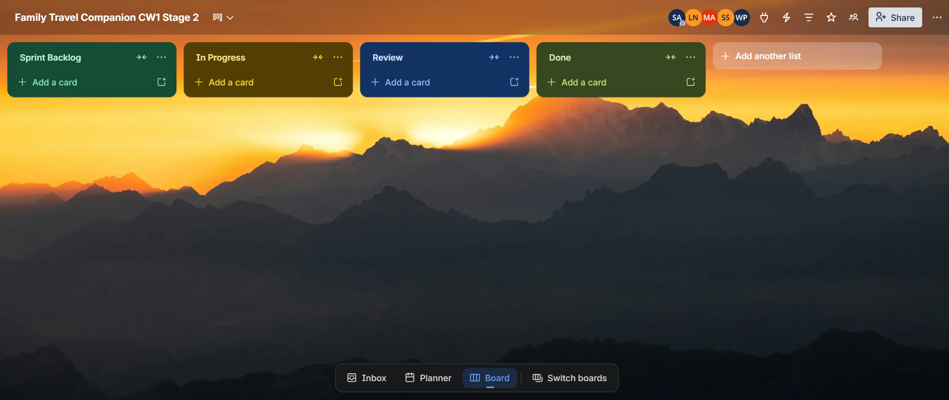
Fig B.1 – Initial Board Creation

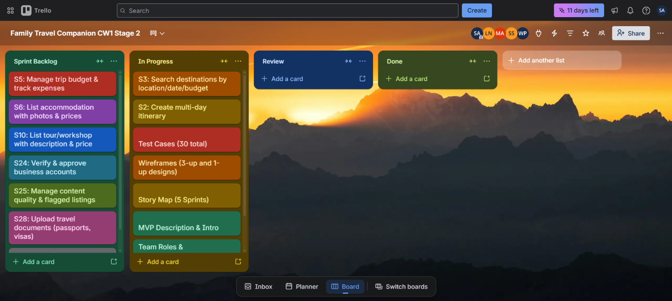
Fig B.2 – Sprint 1 In Progress

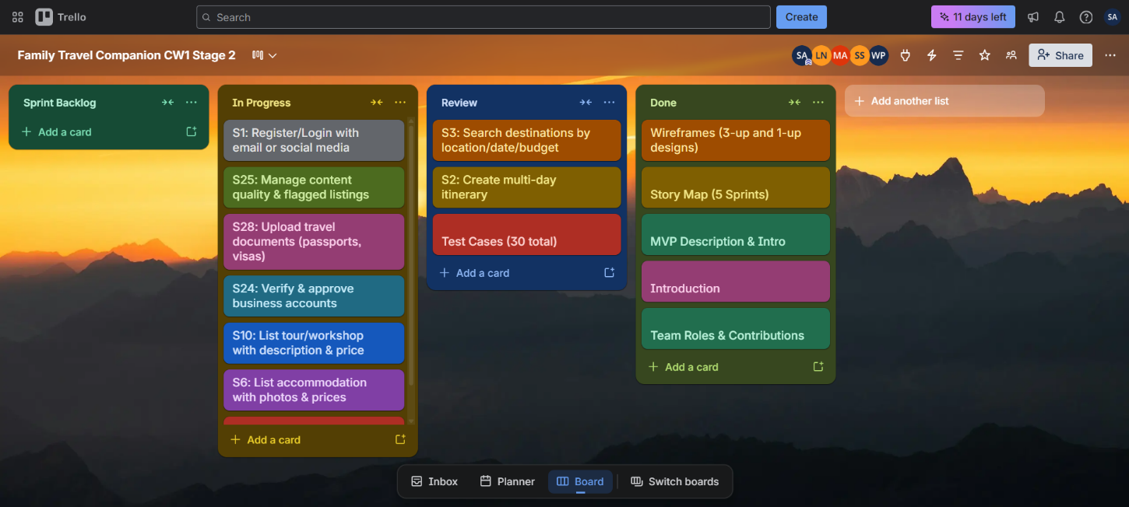
Fig B.3 – Sprint 1 Mid-Sprint

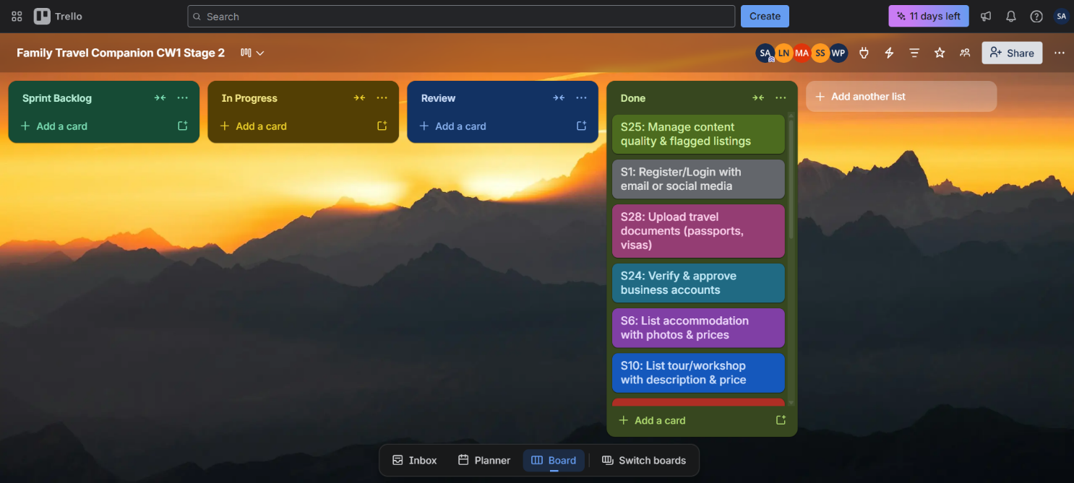
Fig B.4 – Sprint 1 Complete (Done Column Full)

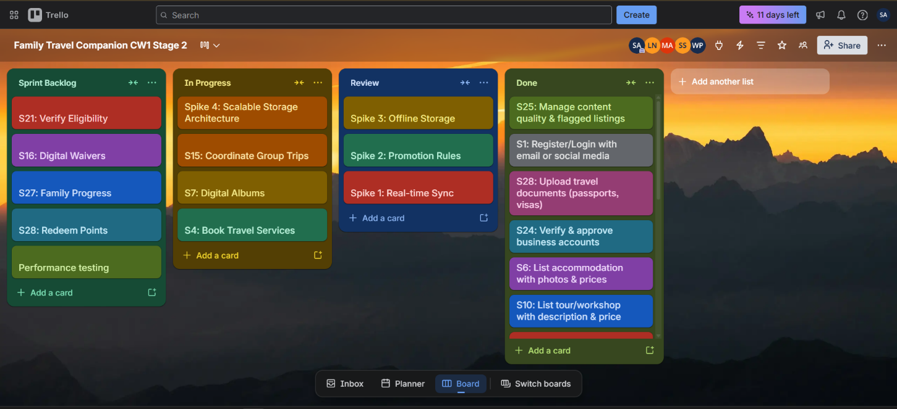
Fig B.1 – Trello Board Sprint 2 Task Allocation

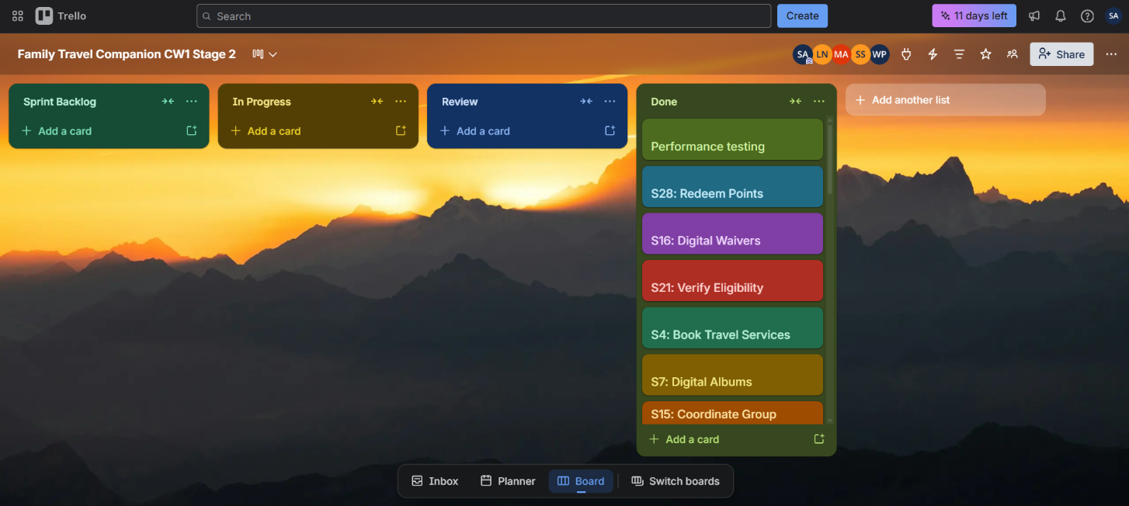
Fig B.5 – Sprint 2 Complete

